Reunion Merchandise

The Schola Cantorum committee is marking the reunion with the opportunity to purchase limited edition Schola-branded polo shirts and umbrellas!

Navy blue polo shirts, with the Schola Cantorum of Oxford logo printed in white on the left chest. These will be available in either unisex or female cut to suit all styles.
Price: £10

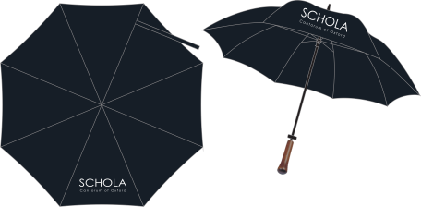
For the first time in Schola’s history, we are also offering Schola umbrellas! These Oxford blue golf-style umbrellas will be smartly branded with the Schola logo on one panel.
Price: £15

If you would like either of these items, please fill out and return the form below by 1st April 2015. The items you order will be available for you to collect at the reunion rehearsal on Friday 1st May, and we ask that you make payment then by cheque or cash. We hope you will want to make the most of this opportunity!

Name: ………………………………………………………………………………….

Email/Tel: ………………………………………………………………………………….

I would like to order a Schola polo shirt (please circle style & size) Cost: £10.00

Cut: Unisex / Female Size: XS / S / M / L / XL

I would like to order a Schola umbrella Cost: £15.00

I undertake to pay for these items on 1st May before the Reunion rehearsal.

Total cost: £……………….. Signed: …………………………………………………….. Date ………………………..

Please return this form by 1st April either electronically to schola.stash@gmail.com or by post to Kathryn Boast,
St Peter’s College, New Inn Hall Street, Oxford OX1 2DL.

If you have any queries, email schola.stash@gmail.com.
Please note: items will only be available if there is sufficient demand.

